

CS3240 Interaction Design

G1: Proposal, Contextual Inquiry, Affinity Diagram and Task Analysis

# Team Members:

**Wong Jun Wei** (A0096579)

Compiled the document, Task Analysis and Data Analysis

**Lim Wei Cheng** (A0101871)

Design Problem and Target Users

**Pearlyn Yeo** (A0084592)

Compiled the document and Appendix, Task Analysis and Requirement Analysis

**Doan Xuan Loc Nguyen** (A0099858)

Contextual Inquiry

# Design Problem Overview

The Integrated Virtual Learning Environment (IVLE) is used by NUS students and lecturers on a daily basis. The purpose of both IVLE is to enrich and facilitate the learning and teaching experience of students and lecturers respectively.

Imagine this scenario.

As an NUS student, David uses the IVLE every day to check for important announcements and to access academic resources. However, the system is plagued by a cluttered GUI and a plethora of redundant features. This makes it frustrating for a David when he wants to smoothly navigate to the information that he needs.

What’s more, not all the information he needs can be found on the IVLE as some NUS teaching staff use external websites such as blogs and Facebook. Thus, to acquire all the necessary information, David will have to transverse back and forth multiple websites. These contributes to an unpleasant user experience, and this can deter the David from using the IVLE as often as he should, thus hindering his learning journey.

David also frequently checks his NUS mail for important emails. However, due to the overwhelming amount of emails he is not interested in and thus regards as spam mail, he finds it tedious to manually filter the mail that he needs from these spam mail. Often, he would find himself missing out on important emails.

We are motivated by such a scenario and hope to come up with a solution so that IVLE can better fulfil its purpose.

Mainly, some of the problems we found out are that:

* Sharing information on IVLE is not straightforward
* Important information is not displayed visibly enough
* Overwhelming amount of information is presented to the user
* Ambiguous labelling of features
* Quite a number of redundant features that users do not use
* IVLE’s cluttered graphical user interface made it confusing to navigate and use
* Difficult to filter important emails from spam

In particular, we have discovered the three key areas of focus which are enhancing learning experience, communication and GUI. These will be elaborated on later.

# Target Users

Since the system in mind is an online platform, it is reasonable for our target users to possess a certain level of tech savviness.

The target users of our choice will be NUS students and teaching staff, since they are the main users of the IVLE system. Most if not all NUS students will use IVLE on a frequent basis, while teaching staff on the other hand, can exercise choice whether to use IVLE or other 3rd party platforms. NUS students and teaching staff also have ready access to the internet and more often than not have a device that can access academic information or resources easily.

Priorities of a NUS student would be to access academic information and resources, to discuss and clarify school work, and to receive important announcements and updates. Priorities of a teaching staff would be to announce important information, upload relevant resources, and to collect submitted assignments.

Since NUS students and teaching staffs are typical online users, what they would like are layouts that are visually appealing to them. They would also like more important details to have higher visibility, and intuitive navigation.

# Contextual Inquiry

|  |  |  |  |  |  |  |
| --- | --- | --- | --- | --- | --- | --- |
| User | Gender | Age | Job Title | Location | Interviewer | Time Taken |
| 1 | Female | Early 20s | Student,  Sociology  year 3 | Home | Justin | 15 minutes |
| 2 | Female | Early 20s | Student,  Business and Economics  year 4 | Home | Justin | 15 minutes |
| 3 | Male | Early 20s | Student,  Computer Science year 2 | Discussion Room | Jun Wei | 1 hour 20 minutes |
| 4 | Male | Early 20s | Student,  Mechanical Engineering  year 3 | Raffles Hall | Pearlyn | 40 minutes |
| 5 | Male | 30s | Professor | Email | Pearlyn | - |
| 6 | Male | Early 20s | Student,  Communications and New Media year 2 | Temasek Hall | Wei Cheng | 30 minutes |

Interview 1+2: the interview was done in a home setting. Some of the difficulties encountered were that the user only uses a very small portion of the program (IVLE) and does not explore other features; therefore it was hard to gather opinions on non-core features. Also due to time constraints, it was not possible to go into details and the interviewee could not elaborate much for each of the main questions.

Interview 3: did not involve many surprises. Also no difficulties because of the nature of the project. Interviewee was also sporting and did not mind exploring features of IVLE he had never used or noticed before.

Interview 5: a face-to-face interview could not be arranged because of time and schedule constraints. Hence it was not possible to ask follow-up questions for the interviewee to elaborate further or to clarify previous information. But on the other hand interviewee did not mind exploring unfamiliar features of IVLE.

Interview 6: one difficulty encountered was that the interviewee does not actively explore IVLE, and does not know about several of its features because of the GUI. But overall the interview went smoothly and followed the given model.

Overall the experience was pleasant, and did not meet with too many difficulties because everyone in the team as well as all interviewees already have had at least a year of experience with IVLE and are therefore very familiar with its core functions. What was surprising was that some interviewees have very different, sometimes opposite opinions on the same topic (some thought IVLE had an obtuse interface while some thought it was straightforward to use)

All of our interviews did not adhere to a very clear sequence and structure, and generally we tended to immediately ask any new follow-up questions that we thought of on the spot. If we had stuck to a more concrete structure for the interview and came up with more detailed and possible follow-up questions beforehand, we might have been able to to gather more substantial and in-depth information.

Also, our interviews were conducted by each of our team members on our own due to time and schedule constraints, therefore one person had to be in charge of asking the questions, listening for the answer and taking notes. This also meant the lack of a moderator for the interviews. This may have contributed to the lack of structure for the interview and possibly prevented us from getting more in-depth and detailed information from our interviewees.

Another common learning point that could be drawn from most of the interview was that it is better to ask more and more detailed questions. For several points in the interviews, we did not follow up some of the questions properly and this gave us some slight problems when we had to create an affinity diagram as we recognised some common usage patterns among our interviewees but did not know for sure the reasons why they came about and could not rely on guesswork and speculation. Follow-up “why” questions are especially useful in generating notes later when creating the affinity diagram as it allows for more specific and in-depth user statements and also helped explain why users form certain habits when using IVLE, as well as some common usage pattern among most users. This gives a better understanding of the problems and difficulties users face when using IVLE as well as the root causes behind them.

All in all the process has yielded important data and insights for our project, and we gained valuable experience in contextual inquiry after conducting the interviews and it will definitely prove to be useful in the future.

Data Analysis

In order to consolidate and analyze the data we gathered from conducting our contextual inquiries, the team went through the process of constructing an affinity diagram.

To initiate this process, we first took turns sharing each of our individual contextual inquiry experiences with the team. As one team member is sharing, others took turns on playing the roles of the scribe or moderator. Despite being limited by the constraints of manpower and time, we managed to generate a total of 123 affinity notes in this first session.

Our next step was to get all these affinity notes onto the wall. We followed a systematic process of doing so. After the affinity notes were split evenly among the team, one team member was nominated to read aloud his/her first note. As the first note is placed on wall, other team members look through their respective stack of affinity notes to find any ones with an affinity to the note on the wall. If any team member discovers a related affinity note, he/she will read that note aloud and place it under the first affinity note forming a column. This process was repeated until all our affinity notes were up on the wall in groupings of columns.

(Reference appendix for images of stage 1)

Throughout this stage, we made sure to adhere to certain guidelines, most important of which was to avoid forming any pre-conceived categories and attempt to fit the affinity notes into them. Another rule-of-thumb we followed was to ensure that our columns did not grow too tall. For example, after the first affinity note highlighting the problem IVLE’s GUI was placed on the wall, we continued to place notes we felt had an affinity of GUI under this same column and it quickly grew to a height of ten notes. At this point, the team will then closely examine this particularly tall column and then pick out the differences among the affinity notes to separate them into shorter columns of Navigation issues and Visual issues. The third guideline we followed was to avoid relating affinity notes by keyword. For example, each team member had a few of affinity notes with the word “webcast” in them but we made sure to read these affinity notes more closely and consider its underlying implications before deciding to group them together or not. These three guidelines enabled us to be more effective in recognizing and creating new distinctions based on the raw data on the affinity notes.

As we proceeded into the second stage – adding Blue labels to describe columns that were formed – of the affinity diagram building process, our team of four split into two groups of pairs. This way, the ideas and label possibilities that we conceive can be evaluated someone else thus resulting in more accurate and meaningful Blue labels. We divided the affinity notes on the wall into two, each pair focusing on the notes on one half of the wall. Once every column has been labelled, the pairs then switched sides to evaluate each other’s work; the finalized Blue labels should present enough information such that there is no need to refer to the individual affinity notes beneath it.

(Refer to appendix for images of stage 2)

Since we were more focused on getting the affinity notes on the wall into rough groupings in the previous stage, one of the guidelines the team defined in this stage is to reorganize a column if it is deemed too incoherent. By doing so, we are able to further discover new distinctions among our affinity notes which will in turn surface more design points for us to work with later. For example, the affinity note U3- 35 “I am not aware of the existence of the flashing-red announcement button and its functionality” initially fell under the affinity type of Cluttered GUI at the end of the first stage, however, after further consideration in the second stage we discovered that it could be grouped together with a few of the other rogue affinity notes that we had left over from the first stage to form a new column with affinity type of Presentation of Noteworthy Information. Another guideline for this stage is to write the Blue labels as though the user is speaking to us. This serves as a reminder that we need to let the data tell the story instead of projecting our own pre-defined categories onto the Blue labels. Using the aforementioned example, the affinity type of Presentation of Noteworthy Information can be labelled as “I want to be alerted for noteworthy information when I access IVLE”.

The final step in the construction of our affinity diagram is the addition of the two higher level labels, Pink labels followed by Green labels. As with the Blue labels, a good Pink label elegantly reveals the key themes of the Blue labels underneath it. On the other hand, Green labels are more abstract and categorical as their purpose is to provide an overview of the key issues.

(Reference appendix for images of stage 3)

The guideline we adopted for deriving Pink labels is similar to that of Blue labels. In particular, Pink labels are also written as though the user is speaking to us. As for the Green labels, we strived to avoid over-generalizing as we did not want them to become a catchall for the Pink labels. This was why we created the Communication Green label even though it only encompasses one Pink label; the Pink label “IVLE should provide an effective communication channel between all users” simply did not fall into either of the previously existing Green labels of Learning Experience and GUI.

At the end of the entire affinity diagram construction, the team was able to uncover and identify the core issues of the current IVLE, namely: Learning experience, Communication, and GUI. A detailed discussion of these three core issues will done in the following components of this write-up.

# Task Analysis

1. **Who is going to use the system?**

The students and teaching staff of the National University of Singapore (NUS)

1. **What tasks do they perform?**

NUS students can acquire class materials and submitting assignments through the work-bin, do graded online assessments, participate in online forum discussion, check timetable, and buy or sell textbooks in used textbook forum.

NUS teaching staff can put up general module information on module front page, disseminate class materials and collecting submissions through the work-bin, create graded online assessments, create forums for discussion, and answer questions posted on forums.

1. **What tasks are desired?**

NUS students want to be able to share files, take notes, clarify questions, and track their academic progress.

Both types of users express a desire to conduct online group discussions, coordinate consultation time as well as converse with other users in real time.

1. **How are the tasks learned?**

Most of the main tasks can be learned through intuition and consistent interaction with available features. A help section exists as a last resort.

1. **Where are the tasks performed?**

The tasks are performed on the IVLE platform itself, using a computer and access to internet.

1. **What's the relationship between user and data?**

NUS students have a high dependency on the data available on IVLE while NUS teaching staffs generate majority of the data available on IVLE.

1. **What other tools does the user have?**

NUS students rely on third party tools and services such as Google Drive, Dropbox, Whatsapp, Google Groups, Facebook, Google, Evernote, NUSmods with Google Calendar.

NUS teaching staff rely on tools such as Module Websites, Skype, and Google Hangouts.

In particular, other than NUSmail, students, TAs and professors often make use of external mailboxes like Gmail for replies because of the spam contents received in the NUSmail. Although platforms are provided and existing, users still make comparisons with external services and pick the better of the two.

1. **How do users communicate with each other?**

Forums and NUSmail are both utilized for communication, but students and professors often make use of personal emails more so than the NUSmail due to the spam contents of the NUSmail which deters communication. Professors also make use of external, third party platforms for communication channels because of the better features provided that IVLE/NUSmail does not have

Students, however, will still email their professors for clarifications instead of the forum due to a few reasons: Anonymity, efficiency and quality. Questions are often being asked repeatedly on the forum, and some students would much rather stay anonymous to avoid unnecessary feedback or judgement from their peers.

1. **How often are the tasks performed?**

NUS students access IVLE frequently on a daily basis during the school term, and NUS teaching staff access IVLE on a regular basis for updates regarding their module or updates from other modules that require them to note.

1. **What are the time constraints on the task?**

There are no time constraints regarding the task; users are able to make use of IVLE for as long as they want to. However, NUS students perform the tasks in a rapid and successive manner, while the NUS teaching staff takes a comparatively longer time to complete.

The main reason is because students often do not want to spend a prolonged period of time on IVLE due to its unappealing factors such as the contents and its visuals.

1. **What happens when things go wrong?**

All users fallback on third party support (refer to 7)

# Requirement Analysis for Solution

With the labeling and classification of the blue labels, we identified three core issues with IVLE, namely Learning Experience, Graphical User Interface and Communication, and eight components required to fulfil user needs for our new solution. These components will serve as the central focus in our new solution. Idea generation and brainstorming will also be taking these aspects into account. We will be elaborating on the eight components that led to the derivation of the core features.

The eight components are as follows:

Firstly, the reinforcement of daily learning through IVLE is the satisfaction of what users need and require in their daily access with IVLE. Aspects such as setting up consultations, viewing academic resources and the planning of schedules and timetables are examples of daily usage of IVLE. An example of such user needs is the expression of interest in the addition of notes on IVLE to better facilitate their learning. Interviewees also hope to be able to ‘make use of IVLE to study notes’ and hence the idea of integrating note-taking features into IVLE. Furthermore, an interviewee specifically stated that ‘setting up consultations with students can be more efficient’. These user statements thus provide greater insights on how IVLE should be geared towards satisfying user needs and wants based on their preferences.

Next, easy sharing of information on IVLE simply suggests a platform for file-sharing services on IVLE. The existing platform does serve this purpose, but this service goes largely unknown due to the immense unpopularity of the usage of this feature. The accessibility of features carrying file-sharing service should be centralized in order to make known to users of IVLE. Current users commented that they often rely on third-party sharing platforms instead of IVLE, suggesting the current negligence of the existing file-sharing services on IVLE.

Another way of sharing of information stems from the IVLE Forum, and interviewees have suggested improvements with regards to the usability of the forum itself. In order to engage users into using the forum, the facilitation of discussions may require a clearer guideline as well as options for anonymity for open feedback and discussions.

Linking closely to information sharing is the accessibility to our academic information on IVLE. Academic information such as school fees, exam timetables and Gradebook should be readily available and accessible to users. Users have also expressed concerns over searching for module weightages as well as their academic progress, questioning the lack of accessibility to such integral tools. A one-stop platform for all these information was also brought up during one of the interviews, where suggestions were made regarding the ‘integration of NUSmail, myISIS, NUS CORS and IVLE’. This reiterates the point of satisfying user needs and wants.

One of the key components that we gathered was the relevance of information displayed on IVLE. This requirement is directed towards the seemingly cluttered interface of IVLE as well as the Login Page. Suggestions for cleaner and simpler interfaces kept resurfacing during the interviews, suggesting the pertinent need for evaluation of the Graphical User Interface of IVLE as a whole. As IVLE is a school portal that caters to a large scope of target users, taking their preferences into consideration should be the central focus in creating better user experience. Throughout the interviews and data analysis, both useful and useless features were singled out by interviewees and displayed through contextual inquiry. Through observations of users using IVLE, it suggests that necessary features should be centralized for better usage and accessibility. This component is derived from interviewees’ lack of knowledge regarding several IVLE features that they later expressed interest with. Hence, the rearrangement of the user interface may provide users with better clarity of the features offered on IVLE.

Similar to relevant information is the display of important information on IVLE. This is in relation to the interface, whereby important or urgent information are not given proper focused space for display. Interviewees also provided feedback about the visual aspects of important information such as the size and aesthetics. IVLE should thus provide a targeted space that is eye-catching for notifications and important information because several interviewees have no knowledge of features such as Student Events and What’s New due to the lack of given attention.

Furthermore, display of important information can also be overpowered in the NUSmail, whereby each user receives several ‘spam’ mails that ends up covering the initial mails that may be of importance to the user. Daily usage of the mail for update and contacts suggests that users want an organized mail without the hassle of constantly dealing with the massive amount of irrelevant mail appearing in their inboxes.

Not forgetting the foundation of the design problem, IVLE should be intuitive, easy to use and a pleasant experience. The idea behind this statement is simply stating that IVLE needs to be user-friendly and does not contain a learning curve of any sorts. This is complemented by the comments regarding misleading labelling and inappropriate iconography of IVLE that may cause confusion in navigation. From the interviewees’ comments regarding the confusion and difficulties of certain features like the subscription of announcements, it suggests that this component, along with the relevance of information, will largely affect the user experience of IVLE. This will also in turn affect the experience of IVLE and the frequency of usage.

Lastly is the social component of IVLE, where a communication channel between all users should be properly established and applied. Discussion platforms on school portals are definitely utilized to a small extent such as the forums, but such existing features still pale in comparison to third party sites. At the same time, the idea of creating profile on IVLE will only make sense if there contains effective use of it besides the Class Roster. The social functions will be able to add value to IVLE, where real-time platforms may even be set up for discussions such as project meetings. Interviewees have commented that even with NUSmail, it is often hard to carry conversations due to the asynchronous timings and amount of unnecessary content found in their inboxes. Hence, this component will serve as better assistance to users who wish to conduct real-time discussions and meetings.

In conclusion, the identification of these features and components will serve as great assistance to our next level of brainstorming and coming up with ideas for the new solution itself according to our core features.

Appendix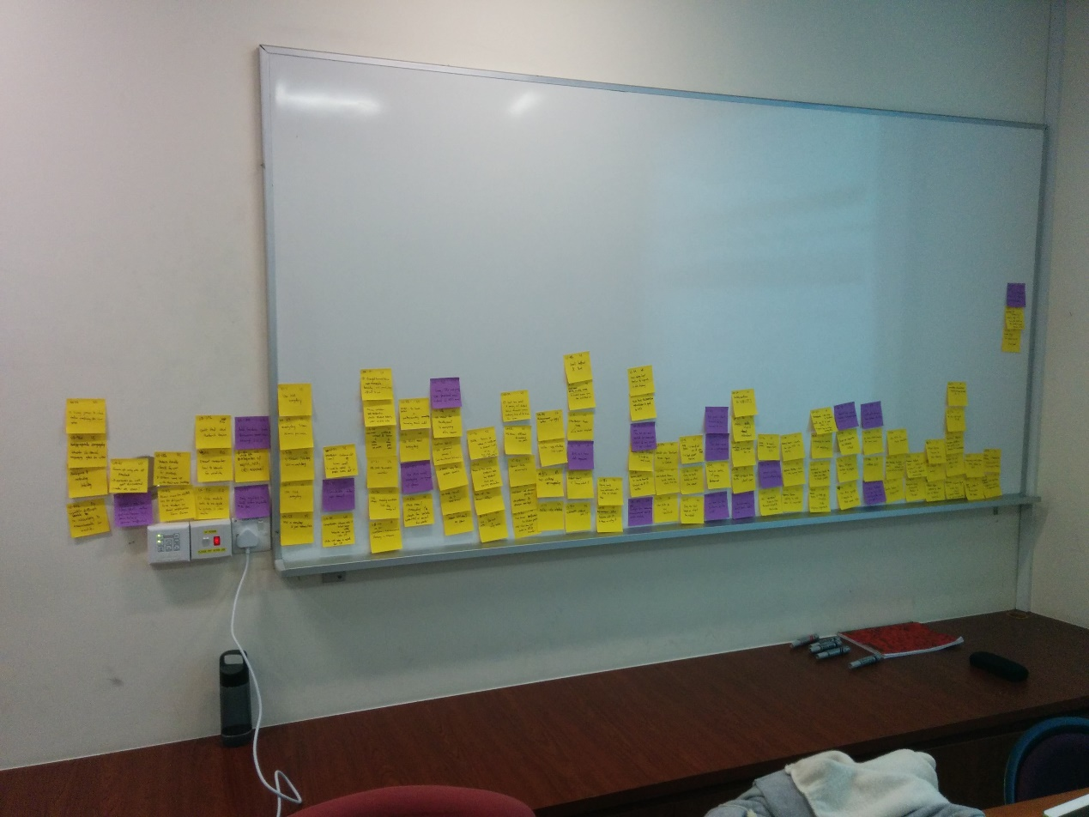

Fig 1. Affinity Diagram Stage 1

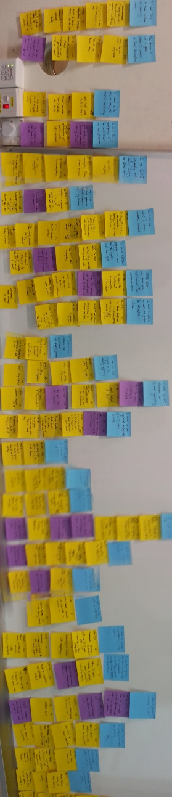

Fig 2. Affinity Diagram Stage 2

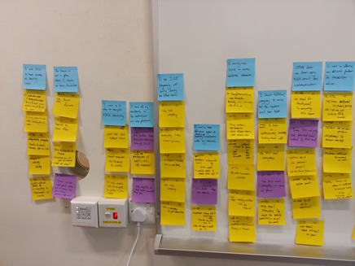 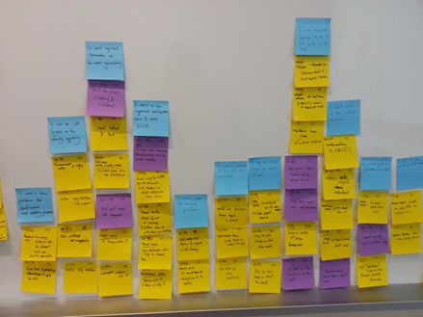

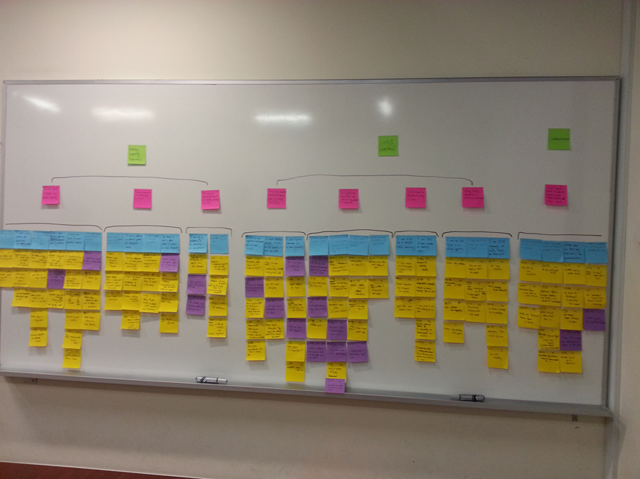

Fig 3. Affinity Diagram Final Stage

Consent Form: IVLE(Integrated Virtual Learning Environment) feedback

I hereby consent to participate in a research study conducted by Wong Jun Wei, Justin, Pearlyn, Wei Cheng for an assignment in National University of Singapore Computer Science 3240, Interaction Design.

I agree to participate in this study the purpose of which is to collect user feedback regarding the usage of the IVLE.

I understand that

The procedures to be used are a generic interview, voice recorder and screen recording of a demonstration.

I will receive no compensation for my participation.

I am free to withdraw before or any time during the study without the need to give any explanation.

All materials and results will be kept confidential, and, in particular, that my name and any identifying or identified information will not be associated with the data.

**Participant**

Name (please print)

Signature Place and Date _______

**Investigator(s)**

Name (please print)

Signature

# Interview Questions

## Target Interviewees

* NUS Students
* Prof
* TA

## Interview Tools

* Screen recording (HyperCam2)
* Voice recording

## Introduction

We are gathering user feedback for IVLE and NUS email

## General Questions

1. What is your name?
2. Which year and what major are you in?

IVLE Questions

1. How often do you use IVLE?
2. What do you use IVLE for?
   1. What about these other features?
3. What is your favorite feature of IVLE?
4. What do you dislike about IVLE?
5. What additional features would you like to see being implemented on IVLE?

Email Questions

1. How often do you use NUS email?
2. What do you use NUS email for?

# Interview Transcripts

## Interview 3

* Year 2 Computer Science Major
* Was a TA in CS1010 and CS2103T

## IVLE

|  |  |  |  |
| --- | --- | --- | --- |
| Feature | Use | Like/Dislike | Preference |
| Workbin | Download class materials |  |  |
| Forum | (TA) Automatically subscribe to email notifications for new forum posts  (TA) answer questions on forum  Only used the forum once to ask question, due to lack of anonymity. | Lack of anonymity. Afraid of asking a “stupid question”.  Find that the amount of questions in CS1010 becomes a little bothersome.  Advises students to google but they do not. | Chooses to drop an email directly to the prof. Using personal email.  Feels that it is difficult generate a proper discussion since a student does not received notifications for forum posts by default  Would like anonymous posting feature. |
| Search | Lookup information on modules  In particular the weightage of each component in the module | Could not remember how to do this when asked to demonstrate | Mentioned it was much easier to use google |
| Multimedia (Webcast Lectures) | Used very little since he always attends lectures. | Finds it boring to listen to the lectures repeatedly.  Difficult to find parts of the video you are actually interested in. | Does not use the webcast lectures as a form of review.  Prefers to look to lecture slide and recollect instead. |
| Weblinks |  | IT’S STUPID | Does not mind that it is redundant though. Feels like it should be utilized more if it already exists. |
| Used Textbook Forum | Used once/twice to acquire textbooks | Could not remember how to find it | Expressed interest in using in the future. |
| Webcast Lectures | Did not know about its existence |  | Expressed interest to use this feature in the future |
| Class Roster | Did not know about its existence | Icon too small | Expressed interest to use this feature in the future. Look up friends taking the same module |
| Class timetable | Did not know about its existence | Icon too small  Difficult to understand in its present form |  |
| Anonymous Feedback | Did not know about its existence | Think it is an important feature  Icon too small | Provided feedback using personal email previously. |
| Consultation | Did not know about its existence | Icon too small | TA Could be useful, especially in terms of coordinating consultations with various students. |
| Announcements | Did not know about its existence. Despite it being flashing red. |  | Expressed interest to use this feature in the future. |
| Groups |  |  | Uses Whatsapp as a platform for discussion within the project group.  Uses Dropbox and google docs to share files with group members. |
| Gradebook | Used only when the prof uses it |  | Every prof should use it so that he can track his progress. |
| Resource Banks | Did not know about its existence | No notification when we tried sharing files | Expressed interest to use this feature in the future if it improves.  Using it especially for school work. |
| Usage | Did not know about its existence |  | Does not care about this feature |
| Profile | Did not know about its existence. (subscriptions) | Encounter difficulty when trying to subscribe to updates | Setting subscriptions for updates on modules  Does not care about profile on IVLE for now.  Would be interested if there is a substantial discussion platform and file sharing features. |
| Distribution Lists | Did not know about its existence.  Ability to email the various mailing lists | Likes the power. | Thinks it’s a bug |
| My Organizer | Did not know about its existence. |  | Uses NUS mods to export his calendar  Would like to see timetable on IVLE |
| Student Events | Did not know about its existence. |  | Would check it if convenient. |
| Help | Did not know about its existence. |  | Would not use it unless really in need |
| Login Page |  |  | Prefers it to be simple |

## NOTES

* Was initially unaware of the left and right side of the workspace page
* Ambiguious, misleading labeling
* Small buttons
* Cluttered GUI
* Inappropriate Iconography (view icon vs search icon)
* Frequency of IVLE usage: three to five times on a school day and not so much on weekends
* MOST IMPORTANT IMPROVEMENT: Filesharing to Discussion platform
* Brought up integration of CORS, myISIS(checking CAP) and IVLE
* Likes the stackoverflow idea: students have more confidence in the answers, can quickly check for similar and popular questions

## NUS Email

* Redirects NUS email to personal email
* Checks it daily, approximately twice a day
* Regards most NUS email as SPAM
* Uses personal email for student-TA contact
* Uses personal email to ask questions to prof
* Likes the idea of integrating NUS email with IVLE so there will be no need for redirect

## Interview 4

* Year 3 majoring in Mechanical Engineering

## IVLE

* Main features used: **Workbin**, **email**
  + **Workbin**:
    - Mainly for lecture notes and tutorials
    - Usually checks everyday for new notes
    - Does not click on anything else other than Webcasts and Forum when needed
  + **Email**:
    - Communicate and chat with professors
    - Updates regarding workbin (Never noticed Notifications on the right)
    - Deletes all other ‘junk’ mail
* Frequency of usage: Daily
* Additional features he wants to have: Chat room with class or professors directly (Did not know about project groups section)

General Comments:

* IVLE is not social. It does not appeal to students like him.
* Visuals and layout unappealing, hence he wants to get out of IVLE as soon as possible each time he logs in.
* Too cluttered with unnecessary information and things students don’t need or care about – Only need main features
* School portals are meant to be this way: Not interesting

Comments on Features:

* **Committees**: What’s this? Do not see the need
* **Webcast Lectures** (Left): Did not know about this, but might be an interesting section for students who want to read other lectures in their free time.
* **Consultation**: Never used before although he knows of its existence. Reason is because no professors ever used it
* **What’s New**: Interesting, but no comments. Not necessary at all.
* **Home Page**: Useless. Only uses the button to enter the portal.
  + **Mobile**: Interesting page actually. But never noticed before
* **Gradebook**: Does not utilize it because professors don’t use it
* **Forum**: Would prefer asking friends or professors through email because it’s clearer and more efficient then the forum.

## Interview 6

* Year 2 Communications and New Media major

## IVLE

* How often: Use IVLE 7days/week, 5times/day, each session approx. 10mins
* Usage: Check announcements, participate in forums, work bin to download lecture slides, library e-resources
* Other usage: Start of the semester will go used textbook forums, or sign up for research programme if module requires.
* Favourite feature: quite straight forward, things are accessible, hierarchy system (more of academic side)
* Easy to navigate.
* Don’t really use non-academic stuff apart from used textbook forum
* Disliked: text is too small, which makes things look cluttered and messy.
* Additional feature I would like: booking of discussion room to be done through IVLE (currently booking is done via NUS libraries website) i.e. more centralised
* Forum discussion groups for different tutorial groups are messy as the labels are the same(all labelled as forum), better if system only shows forum groups that I am supposed to be in
* Instead of having to look at the top right corner for notifications, would be nice to have badges for new announcements right beside the announcement word.
* Thinks that using groups to check class roster might be confusing for new user as it is quite out of the way.
* IVLE will be a lot better platform if I can customize what I can see on the page (so that do not have the problem of clutter)
* The main student module section have too much words, thus can be daunting to a new user
* Have tabs for subjects instead (easier to navigate)
* IVLE not a particularly difficult system to use

## Email

* Use email everyday whenever I get a notification on my phone (synchronised with phone)
* Usage mainly academic stuff (check announcements, see if lecturer uploads slides or resources not posted on IVLE)
* Some lecturers and tutors also do not use nus mail, use personal email instead.

## IVLE demo

* After logging in, check top right for notifications
* Then check the announcements, after which, if required, go to workbin to download
* Used the groups to check for class roster (clicks on module code then navigate to the groups instead of clicking the top left corner)
* Doesn’t use consultation to book consultations. Will email instead. Tutors will also give personal emails (they do not use the IVLE for consultations also)
* IVLE organizer is not appealing, would be better if colour coded. Will use it if it is better than 3rd party timetable planner like nusmods
* Do not care about the students events, therefore do not use it, better to hide it away to clear the clutter
* Do not see a need for the profile/subscription tab
* Only use forum is class requires me to use it. Discussion and questions rather to be done in face-to-face. Because people replying to queries will take time, so have delay and inefficient
* Do not see myself using the bookmarks tab or communities tab
* Do not use the top toolbar (except the logout button when using public computer)
* Only access myISIS(only to check exam timetable and pay school fees), library portal and used textbook forums under the notifications sidebar.
* Wouldn’t use the webcast lectures for other modules, because internet would have better resources.
* Overall, interface of IVLE cluttered. For a new user, things might not be clear at the start, but once you get it, you get it.

# G1 Meeting Agenda

## Go through G1 Outline

## Consolidate Interviews

* Summary of each contextual interview, including the person’s gender, approximate age, job title, the location of the interview, who conducted and who took notes, how long it took to complete, etc.
* Also, include any difficulties you had or surprises you encountered in conducting the contextual interview.
* ***Generate affinity notes from data gathered***

## Analyze Data

* ***Construct affinity diagram from bottom up***
* Level One (Grouping affinity notes)
* Level Two (Generate user stories from groups)
* Level Three and Four
* The goal is to summarize, prioritize, and find trends, patterns, by finding the rules of the world, pushing knowledge up the hierarchy, and making data more presentable.
* Explain differences, contradictions, generate new knowledge, more design ideas, more concepts.

## Answer Task Analysis Questions

1. Who is going to use the system?
2. What tasks do they now perform?
3. What tasks are desired?
4. How are the tasks learned?
5. Where are the tasks performed?
6. What's the relationship between user and data?
7. What other tools does the user have?
8. How do users communicate with each other?
9. How often are the tasks performed?
10. What are the time constraints on the task?
11. What happens when things go wrong?

## Coming up with Solutions based on Data Analysis

Based on the task analysis and contextual inquiry, now describe the main features and components needed for the new solution. Justify your decisions and analysis. For example, don’t just give the final requirements.

***Convince the reader that your requirement analysis is based on data discovered in the contextual inquiry.***

## Split the Work